**4.1.2 GSM System architecture:**

* GSM comes with a hierarchical, complex system architecture comprising many entities, interfaces, and acronyms.
* A GSM system consists of three subsystems, the **radio sub system (RSS)**, the **network and switching subsystem (NSS)**, and the **operation subsystem (OSS)**.

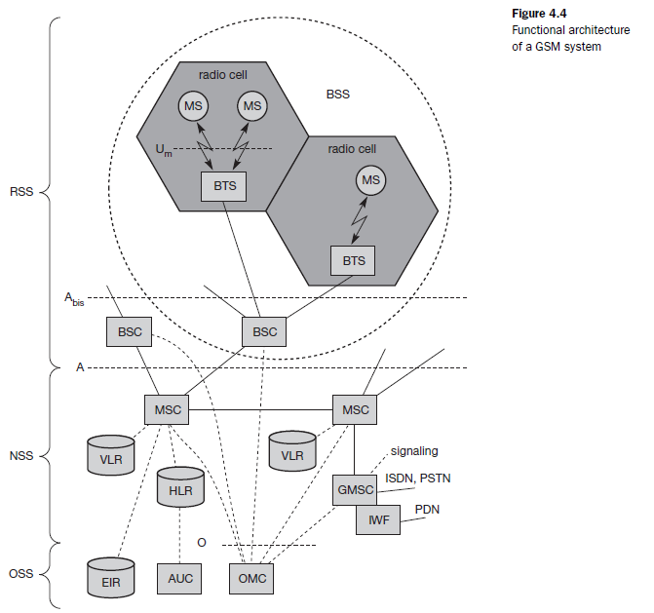

**Radio subsystem:**

* The **radio subsystem (RSS)** comprises all radio specific entities
* The **mobile stations (MS)** and the **base station subsystem (BSS)**.
* The connection between the RSS and the NSS via the **A interface** (solid lines) and the connection to the OSS via the **O interface.**

**Base station subsystem (BSS)**: A GSM network comprises many BSSs, each controlled by a base station controller (BSC).

* The BSS performs all functions necessary to maintain radio connections to an MS, coding/decoding of voice, and rate adaptation to/from the wireless network part.
* The BSS contains several BTSs.

**Base transceiver station (BTS)**: A BTS comprises all radio equipment.

* Antennas, signal processing, amplifiers necessary for radio transmission.
* A BTS can form a radio cell or, using sectorized antennas, several cells and is connected to MS via the **Um interface** and to the BSC via the **Abis interface**.
* The Um interface contains all the mechanisms necessary for wireless transmission.
* The Abis interface consists of 16 or 64 kbit/s connections.

**Base station controller (BSC)**: The BSC basically manages the BTSs.

* It reserves radio frequencies, handles the handover from one BTS to another within the BSS, and performs paging of the MS.
* The BSC also multiplexes the radio channels onto the fixed network connections at the A interface.

**Mobile station (MS)**: The MS comprises all user equipment and software needed for communication with a GSM network.

* An MS consists of user independent hard- and software and of the **subscriber identity module**

**(SIM),** which stores all user-specific data that is relevant to GSM.

* MS can be identified via the **international mobile equipment identity (IMEI)**, a user can personalize any MS using his or her SIM.
* The SIM card contains many identifiers and tables, such as card-type, serial number, a list of subscribed services, a **personal identity number (PIN)**, a **PIN unblocking key (PUK)**, an **authentication key Ki**, and the **international mobile subscriber identity (IMSI).**
* MS can also offer other types of interfaces to users with display, loudspeaker, microphone, and programmable soft keys.

**Network and switching subsystem:**

* The “heart” of the GSM system is formed by the **network and switching subsystem (NSS)**.
* The NSS connects the wireless network with standard public networks, performs handovers between different BSSs.
* Functions for worldwide localization of users and supports charging, accounting, and roaming of users between different providers in different countries.
* The NSS consists of the following switches and databases:

**Mobile services switching center (MSC)**: MSCs are high-performance digital ISDN switches.

* They set up connections to other MSCs and to the BSCs via the A interface, and form the fixed backbone network of a GSM system.
* An MSC manages several BSCs in a geographical region.
* A **gateway MSC (GMSC)** has additional connections to other fixed networks, such as **PSTN** and **ISDN**.
* An MSC can also connect to **public data networks (PDN)** such as X.25.
* An MSC handles all signaling needed for connection setup, connection release and handover of connections to other MSCs.

**Home location registers (HLR)**: The HLR is the most important database in a GSM system as it stores all user-relevant information.

* This comprises static information, such as the **mobile subscriber ISDN number (MSISDN)**, subscribed services, and the **international mobile subscriber identity (IMSI).**
* Dynamic information is also needed, e.g., the current **location area (LA)** of the MS, the **mobile subscriber roaming number (MSRN)**, the current VLR and MSC.
* As soon as an MS leaves its current LA, the information in the HLR is updated. This information

is necessary to localize a user in the worldwide GSM network.

**Visitor location registers (VLR)**: The VLR associated to each MSC is a dynamic database which stores all important information needed for the MS users currently in the LA that is associated to the MSC.

* If a new MS comes into an LA the VLR is responsible for, it copies all relevant information for this user from the HLR.

**Operation subsystem:**

* The third part of a GSM system, the **operation subsystem (OSS)**, contains the necessary functions for network operation and maintenance.
* The following entities have been defined:

**Operation and maintenance center (OMC)**: The OMC monitors and controls all other network entities via the O interface (SS7 with X.25).

* OMC management functions are traffic monitoring, status reports of network entities, subscriber and security management, or accounting and billing.

**Authentication centre (AuC)**: As the radio interface and mobile stations are particularly vulnerable, a separate AuC has been defined to protect user identity and data transmission.

* The AuC contains the algorithms for authentication as well as the keys for encryption and generates the values needed for user authentication in the HLR.

**Equipment identity registers (EIR)**: The EIR is a database for all IMEIs. It stores all device identifications registered for this network.

* As MSs are mobile, they can be easily stolen. With a valid SIM, anyone could use the stolen MS. The EIR has a blacklist of stolen (or locked) devices. In theory an MS is useless as soon as the owner has reported a theft.

**4.1.3 Radio Interface**

* The most interesting interface in a GSM system is Um, the radio interface.
* GSM implements SDMA using cells with BTS and assigns an MS to a BTS.
* FDD is used to separate downlink and uplink.
* Each of the 248 channels is additionally separated in time via a **GSM TDMA frame**.
* Each 200 kHz carrier is subdivided into frames that are repeated continuously.
* A frame is again subdivided into 8 **GSM time slots.**

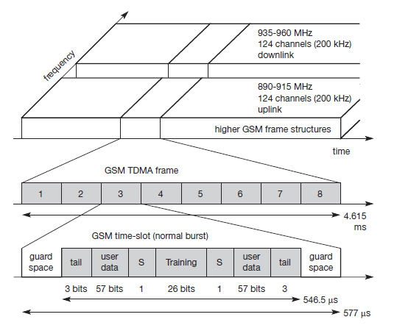

* Data is transmitted in small portions, called **bursts**.
* The burst is only 546.5 *μ*s long and contains 148 bits. The remaining 30.5 *μ*s are used as **guard space** to avoid overlapping with other bursts.
* The first and last three bits of a normal burst (**tail**) are all set to 0 and can be used to enhance the receiver performance.
* The **training** sequence in the middle of a slot is used to adapt the parameters of the receiver.
* A flag **S** indicates whether the **data** field contains user or network control data.

**Logical channels and frame hierarchy**

* A physical channel consists of a slot, logical channel C1 that only takes up every fourth slot and another logical channel C2 that uses every other slot.
* Both logical channels could use the same physical channel with the pattern C1C2xC2C1C2xC2C1 etc.
* GSM specifies two basic groups of logical channels, i.e., traffic channels and control channels

**Traffic channels (TCH)**: GSM uses a TCH to transmit user data.

* Two basic categories of TCHs have been defined, i.e., **full-rate TCH (TCH/F)** and **half-rate TCH (TCH/H)**.
* A TCH/F has a data rate of 22.8 kbit/s, whereas TCH/H only has 11.4 kbit/s.
* The standard codecs for voice are called **full rate** (FR, 13 kbit/s) and **half rate** (HR, 5.6 kbit/s).

**Control channels (CCH)**: Many different CCHs are used in a GSM system to control medium access, allocation of traffic channels or mobility management.

* Three groups of control channels have been defined.

**Broadcast control channel (BCCH)**: A BTS uses this channel to signal information to all MSs within a cell.

**Common control channel (CCCH)**: All information regarding connection setup between MS and BS is exchanged via the CCCH.

**Dedicated control channel (DCCH)**: While the previous channels have all been unidirectional, the following channels are bidirectional.

**Frame hierarchy**

* Combining 26 multiframes with 51 frames or 51 multiframes with 26 frames to form a **superframe**.
* 2,048 superframes build a **hyperframe** with a duration of almost 3.5 hours.

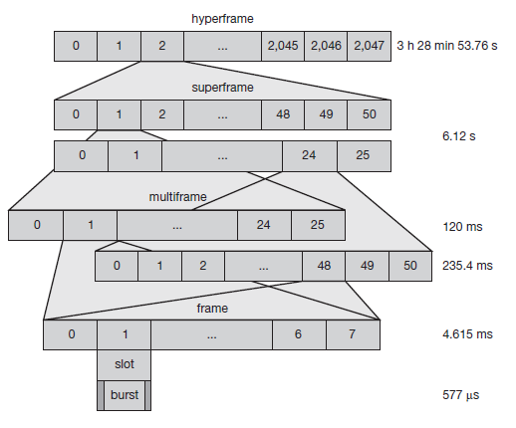

**4.1.4 Protocols**

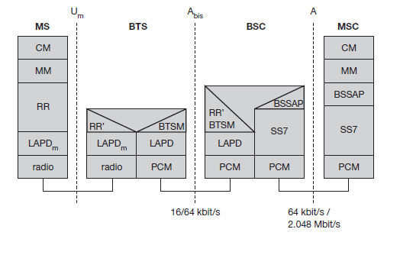

* Diagram shows the protocol architecture of GSM with signaling protocols

**Layer 1**, the physical layer, handles all **radio**-specific functions.

This includes the creation of bursts according to the five different formats.

* **Multiplexing** of bursts into a TDMA frame
* **synchronization** with the BTS, detection of idle channels
* Measurement of the **channel qualit**y on the downlink.
* The physical layer at Um uses GMSK for digital **modulation.**
* Performs **encryption/decryption** of data.
* The main tasks of the physical layer comprise **channel coding** and **error detection/correction.**
* Channel coding makes extensive use of different **forward error correction (FEC)** schemes.
* The GSM physical layer tries to correct errors, but it does not deliver erroneous data to the higher layer.
* The physical layer also contains special functions, such as **voice activity detection (VAD),** which transmits voice data only when there is a voice signal.

**Layer 2,**

* Signaling between entities in a GSM network requires higher layers. For this purpose, the **LAPDm** protocol has been defined at the Um interface for **layer two**.
* LAPDm, link access procedure for the D-channel (**LAPD**) in ISDN systems, which is a version of HDLC.
* LAPDm is a lightweight LAPD because it does not need synchronization flags or checksumming for error detection.
* LAPDm offers reliable data transfer over connections, re-sequencing of data frames, and flow control.
* Further services provided by LAPDm include segmentation and reassembly of data and acknowledged/unacknowledged data transfer.

**Layer 3**

* The network layer in GSM, **layer three**, comprises several sublayers.
* The lowest sublayer is the **radio resource management (RR)**.
* The functions of RR’ are supported by the BSC via the **BTS management (BTSM)**.
* The main tasks of RR are setup, maintenance, and release of radio channels.
* RR also directly accesses the physical layer for radio information and offers a reliable connection to the next higher layer.

**Mobility management (MM)** contains functions for registration, authentication, identification, location updating, and the provision of a **temporary mobile subscriber identity (TMSI)** that replaces the **nternational mobile subscriber identity (IMSI)** and which hides the real identity of an MS user over the air interface.

While the IMSI identifies a user, the TMSI is valid only in the current location area of a VLR. MM offers a reliable connection to the next higher layer.

Finally, the **call management (CM)** layer contains three entities: **call control (CC)**, **short message service (SMS)**, and **supplementary service (SS)**.

SMS allows for message transfer using the control channels SDCCH and SACCH.

CC provides a point-to-point connection between two terminals and is used by higher layers for call establishment, call clearing and change of call parameters.

Data transmission at the physical layer typically uses **pulse code modulation (PCM)** systems.

**Signaling system No. 7 (SS7)** is used for signaling between an MSC and a BSC.

This protocol also transfers all management information between MSCs, HLR, VLRs, AuC, EIR, and OMC.

**4.1.5 Localization and calling**

One fundamental feature of the GSM system is the automatic, worldwide localization of users.

The system always knows where a user currently is, and the same phone number is valid worldwide.

To provide this service, GSM performs periodic location updates even if a user does not use the mobile station.

GSM very attractive: one device, over 190 countries.

To locate an MS and to address the MS, several numbers are needed:

**Mobile station international ISDN number (MSISDN):** The only important number for a user of GSM is the phone number. Remember that the phone number is not associated with a certain device but with the SIM, which is personalized for a user.

The MSISDN follows the ITU-T standard E.164 for addresses as it is also used in fixed ISDN networks. This number consists of the **country code (CC)** (e.g., +49 179 1234567 with 49 for Germany), the **national destination code (NDC)** (i.e., the address of the network provider, e.g., 179), and the **subscriber number (SN)**.

**International mobile subscriber identity (IMSI):** GSM uses the IMSI for internal unique identification of a subscriber. IMSI consists of a **mobile country code (MCC)** (e.g., 240 for Sweden, 208 for France), the **mobile network code (MNC)** (i.e., the code of the network provider), and finally the **mobile subscriber identification number (MSIN)**.

**Temporary mobile subscriber identity (TMSI):** To hide the IMSI, which would give away the exact identity of the user signaling over the air interface, GSM uses the byte TMSI for local subscriber identification.

**Mobile station roaming number (MSRN):** Another temporary address that hides the identity and location of a subscriber is MSRN. The VLR generates this address on request from the MSC, and the address is also stored in the HLR.

MSRN contains the current **visitor country code (VCC)**, the **visitor national destination code (VNDC)**, the identification of the current MSC together with the subscriber number. The MSRN helps the HLR to find a subscriber for an incoming call.

All these numbers are needed to find a subscriber and to maintain the connection with a mobile station.

**4.1.6 Handover**

* Cellular systems require **handover** procedures, as single cells do not cover the whole service area.
* A handover should not cause a cut-off, also called **call drop**. GSM aims at maximum handover duration of 60 ms.
* There are two basic reasons for a handover.

The mobile station **moves out of the range** of a BTS or a certain antenna of a BTS respectively. The received **signal level** decreases continuously until it falls below the minimal requirements for communication.

The wired infrastructure (MSC, BSC) may decide that the **traffic in one cell is too high** and shift some MS to other cells with a lower load (if possible). Handover may be due to **load balancing**.

* Four possible handover scenarios in GSM:

**Intra-cell handover:** Within a cell, narrow-band interference could make transmission at a certain frequency impossible. The BSC could then decide to change the carrier frequency (scenario 1).

**Inter-cell, intra-BSC handover:** This is a typical handover scenario. The mobile station moves from one cell to another, but stays within the control of the same BSC. The BSC then performs a handover, assigns a new radio channel in the new cell and releases the old one (scenario 2).

I**nter-BSC, intra-MSC handover:** As a BSC only controls a limited number of cells; GSM also has to perform handovers between cells controlled by different BSCs. This handover then has to be controlled by the MSC (scenario 3).

**Inter MSC handover:** A handover could be required between two cells belonging to different MSCs. Now both MSCs perform the handover together (scenario 4).

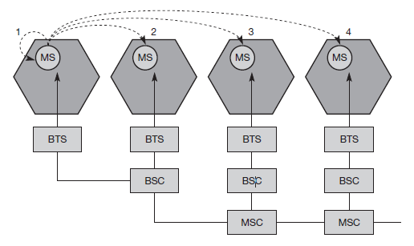

**4.1.7 Security**

GSM offers several security services using confidential information stored in the AuC and in the individual SIM.

The SIM stores personal, secret data and is protected with a PIN against unauthorized use.

The security services offered by GSM are:

**Access control and authentication:** The first step includes the authentication of a valid user for the SIM. The user needs a secret PIN to access the SIM.

**Confidentiality:** All user-related data is encrypted. After authentication, BTS and MS apply encryption to voice, data, and signaling.

This confidentiality exists only between MS and BTS, but it does not exist end-to-end or within the whole fixed GSM/telephone network.

**Anonymity:** To provide user anonymity, all data is encrypted before transmission, and user identifiers are not used over the air. GSM transmits a temporary identifier (TMSI), which is newly assigned by the VLR after each location update. Additionally, the VLR can change the TMSI at any time.

Three algorithms have been specified to provide security services in GSM. **Algorithm A3** is used for **authentication**, **A5** for **encryption**, and **A8** for the **generation of a cipher key**.

In the GSM standard only algorithm A5 was publicly available, whereas A3 and A8 were secret.

**Authentication**

* Authentication is based on the SIM, which stores the **individual authentication key Ki**, the **user identification IMSI**, and the algorithm used for authentication **A3**.
* Authentication uses a challenge-response method.

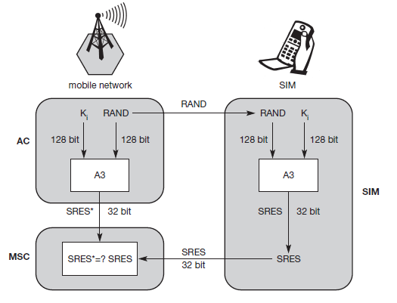

* The access control AC generates a random number **RAND** as challenge, and the SIM within the MS answers with **SRES** (signed response) as response.
* For authentication, the VLR sends the random value RAND to the SIM. Both sides, network and subscriber module, perform the same operation with RAND and the key Ki, called A3. The MS sends back the SRES generated by the SIM; the VLR can now compare both values. If they are the same, the VLR accepts the subscriber, otherwise the subscriber is rejected.

**Encryption**

* To ensure privacy, all messages containing user-related information are encrypted in GSM over the air interface.
* After authentication, MS and BSS can start using encryption by applying the cipher key Kc.
* Kc is generated using the individual key Ki and a random value by applying the algorithm A8.

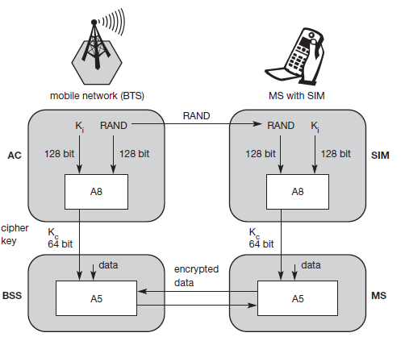

* MS and BTS can now encrypt and decrypt data using the algorithm A5 and the cipher key Kc.
* Kc should be a 64 bit key – which is not very strong, but is at least a good protection against simple eavesdropping.

**4.1.8 New data services**

* To enhance the data transmission capabilities of GSM, two basic approaches are possible.

1. **High speed circuit switched data (HSCSD)**
2. **General packet radio service (GPRS)**

**HSCSD**

* A straightforward improvement of GSM’s data transmission capabilities is **high speed circuit switched data (HSCSD)**, which is available with some providers.
* In this system, higher data rates are achieved by bundling several TCHs.
* An MS requests one or more TCHs from the GSM network.
* It allocates several TDMA slots within a TDMA frame.
* This allocation can be asymmetrical, i.e., more slots can be allocated on the downlink than on the uplink.
* For *n* channels, HSCSD requires *n* times signaling during handover, connection setup and release.

**GPRS**

The next step toward more flexible and powerful data transmission avoids the problems of HSCSD by being fully packet-oriented.

The **general packet radio service (GPRS)** provides packet mode transfer for applications that exhibit traffic patterns such as frequent transmission of small volumes.

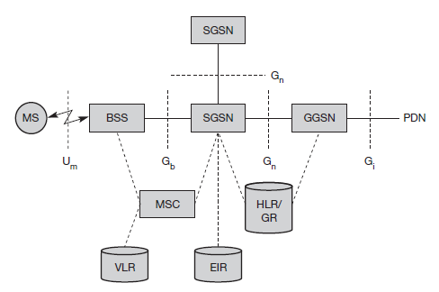

The **GPRS architecture** introduces two new network elements, which are called **GPRS support nodes (GSN)** and are in fact routers.

The **gateway GPRS support node (GGSN)** is the interworking unit between the GPRS network and external **packet data networks (PDN)**.

The other new element is the **serving GPRS support node (SGSN)** which supports the MS via the Gb interface.

The protocol architecture of the transmission plane for GPRS.

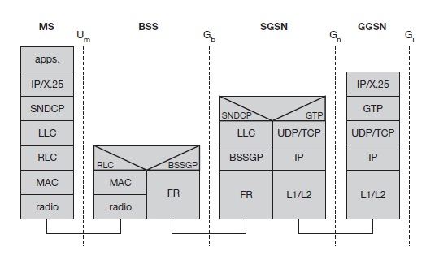

A **base station subsystem GPRS protocol (BSSGP)** is used to convey routing and QoS-related information between the BSS and SGSN.

**GPRS tunnelling protocol (GTP)** can use two different transport protocols, either the reliable **TCP** (needed for reliable transfer of X.25 packets) or the non-reliable **UDP** (used for IP packets).

The **subnetwork dependent convergence protocol (SNDCP)** is used between an SGSN and the MS.

**4.2 DECT**

Another fully digital cellular network is the **digital enhanced cordless telecommunications (DECT)** system specified by ETSI, Formerly also called **digital European cordless telephone and digital European cordless telecommunications.**

* DECT replaces older analog cordless phone systems such as CT1 and CT1+.
* These analog systems only ensured security to a limited extent as they did not use encryption for data transmission and only offered a relatively low capacity.
* DECT is also a more powerful alternative to the digital system CT2.
* DECT is mainly used in offices, on campus, at trade shows, or in the home. Furthermore, access points to the PSTN can be established within, e.g., railway stations, large government buildings and hospitals.
* A big difference between DECT and GSM exists in terms of cell diameter and cell capacity.
* GSM is designed for outdoor use with a cell diameter of up to 70 km, the range of DECT is limited to about 300 m from the base station.
* DECT works at a frequency range of 1880–1990 MHz offering 120 full duplex channels.
* Time division duplex (TDD) is applied using 10 ms frames.
* The TDD mechanism, 12 slots are used as uplink, 12 slots as downlink.
* The digital modulation scheme is GMSK.

**4.2.1 System architecture**

* Different DECT entities can be integrated into one physical unit.

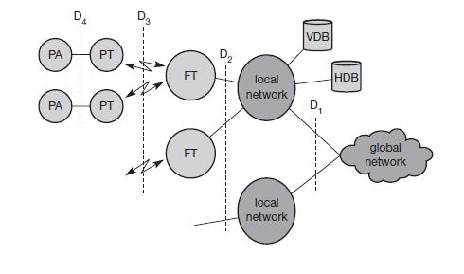

* A **global network** connects the local communication structure to the outside world and offers its services via the interface D1.
* Global networks could be integrated services digital networks (ISDN), public switched telephone networks (PSTN), public land mobile networks (PLMN).
* The services offered by these networks include transportation of data and the translation of addresses and routing of data between the local networks.
* **Local networks** in the DECT context offer local telecommunication services that can include everything from simple switching to intelligent call forwarding, address translation etc.
* **Home data base (HDB)** and **visitor data base (VDB)** both databases support mobility with functions that are similar to those in the **HLR** and **VLR** in GSM systems.
* The DECT core network consists of the **fixed radio termination (FT)** and the **portable radio termination (PT)**, and basically only provides a multiplexing service.
* Several portable applications (PA) can be implemented on a device.

**4.2.2 Protocol architecture**

* The DECT protocol reference architecture follows the OSI reference model.

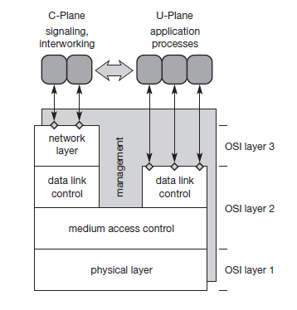

* Diagram shows the layers covered by the standard: the physical layer, medium access control, and data link control for both the **control plane (C-Plane)** and the **user plane (U-Plane)**.
* An additional network layer has been specified for the C-Plane, so that user data from layer two is directly forwarded to the U-Plane.
* A management plane vertically covers all lower layers of a DECT system.

**Physical layer:**

* The physical layer comprises all functions for modulation/demodulation, incoming signal detection, sender/receiver synchronization, and collection of status information for the management plane.
* On request from the MAC layer, the physical layer assigns a channel for data transmission.

**Medium access control layer:**

* The medium access control (MAC) layer establishes, maintains, and releases channels for higher layers by activating and deactivating physical channels.
* MAC multiplexes several logical channels onto physical channels.
* Logical channels exist for signaling network control, user data transmission, paging, or sending Broadcast messages.
* Additional services offered include segmentation/reassembly of packets and error control/error correction.

**Data link control layer:**

* The **data link control (DLC)** layer creates and maintains reliable connections between the mobile terminal and the base station.
* Two services have been defined for the **C-Plane**: a **connectionless broadcast** service and a **point-to-point** protocol.
* Several services exist for the **U-Plane,** a forward error correction service, rate adaptation services, and services for future enhancements.

**Network layer:**

* This layer provides services to request, check, reserve, control, and release resources at the fixed station.
* The **mobility management (MM)** within the network layer is responsible for identity management, authentication, and the management of the location data bases.
* **Call control (CC)** handles connection setup, release, and negotiation.
* Two message services, the **connection oriented message service (COMS)** and the **connectionless message service (CLMS)** transfer data to and from the interworking unit that connects the DECT system with the outside world.

**4.3 TETRA**

* Trunked radio systems constitute another method of wireless data transmission.
* These systems use many different radio carriers but only assign a specific carrier to a certain user for a short period of time according to demand.
* TETRA offers two standards: the **Voice+Data (V+D)** service and the **packet data optimized (PDO)** service.
* While V+D offers circuit-switched voice and data transmission.
* PDO only offers packet data transmission, either connection-oriented to connect to X.25 or connectionless for the ISO CLNS (connectionless network service).
* V+D connection modes comprise unicast and broadcast connections, group communication within a certain protected group.
* TETRA also offers bearer services of up to 28.8 kbit/s for unprotected data transmission and 9.6 kbit/s for protected transmission.
* Examples for end-to-end services are call forwarding, call barring, identification, call hold, call priorities, emergency calls and group joins.
* The system architecture of TETRA is very similar to GSM.
* Several frequencies have been specified for TETRA which uses FDD.
* Modulation is DQPSK.
* While V+D uses up to four TDMA voice or data channels per carrier, PDO performs statistical multiplexing.
* The typical **TDMA frame structure** of TETRA.

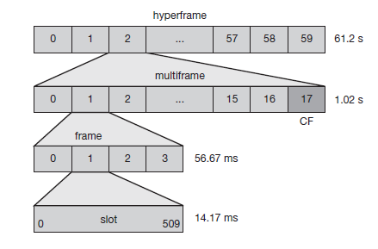

* TETRA offers **traffic channels (TCH)** and **control channels (CCH)** similar to GSM.
* Typical TCHs are TCH/S for voice transmission, and TCH/7.2, TCH/4.8, TCH/2.4 for data transmission.
* TETRA offers additional services like group call, acknowledged group call, broadcast call, and discreet listening.

**4.4 UMTS and IMT-2000**

**5. Satellite systems**

* Satellite communication introduces system supporting mobile communications.
* Satellites offer global coverage without wiring costs for base stations.

**5.1 History**

Satellite communication began after the Second World War. Scientists knew that is was possible to build rockets that could carry radio transmitters into space.

* 1957 -first satellite SPUTNIK-The satellite was launched by the Soviet Union and the event chocked the Western world.
* 1965- First commercial geostationary satellite Satellite “Early Bird“(INTELSAT I).
* INTELSAT 2 followed in 1967, INTELSAT 3 in 1969.
* Three MARISAT satellites went into operation in 1976 which offered worldwide maritime communication.
* 1982- First mobile satellite telephone system INMARSAT-A.
* INMARSAT-C became the first satellite system to offer mobile phone and data services.
* In 1993- Satellite telephone systems finally became fully digital with INMARSAT-M.
* 1998 - Global satellite systems for small mobile phones.

**5.2 Applications**

Traditionally, satellites have been used in the following areas:

**Weather forecasting:** Several satellites deliver pictures of the earth using, e.g., infra red or visible light. Without the help of satellites, the forecasting of hurricanes would be impossible.

**Radio and TV broadcast satellites:** Hundreds of radio and TV programs are available via satellite.

**Military satellites:** One of the earliest applications of satellites was their use for carrying out espionage. Many communication links are managed via satellite because they are much safer from attack by enemies.

**Satellites for navigation:** Even though it was only used for military purposes in the beginning, the global positioning system (GPS) is nowadays well-known and available for everyone.

* In the context of mobile communication, the capabilities of satellites to transmit data is of particular interest.

**Global telephone backbones:** One of the first applications of satellites for communication was the establishment of international telephone backbones.

**Connections for remote or developing areas:** Due to their geographical location many places all over the world do not have direct wired connection to the telephone network or the internet.

The current state of the infrastructure of a country. Satellites now offer a simple and quick connection to global networks.

**Global mobile communication:** The latest trend for satellites is the support of global mobile data communication.

The basic purpose of satellites for mobile communication is not to replace the existing mobile phone networks, but to extend the area of coverage.

A classical scenario for satellite systems supporting global mobile communication, Depending on its type, each satellite can cover a certain area on the earth with its beam.

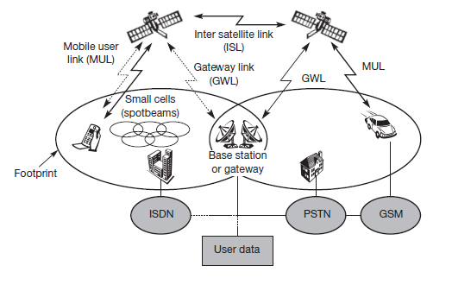

**5.3 Basics**

* Satellites orbit around the earth.
* Depending on the application, these orbits can be circular or elliptical.
* Satellites in circular orbits always keep the same distance to the earth’s surface following a simple law:

The attractive force *Fg* of the earth due to gravity equals *m·g*·(*R/r*)2.

The centrifugal force *Fc* trying to pull the satellite away equals *m·r·*ω2.

The variables have the following meaning:

*m* is the mass of the satellite;

*R* is the radius of earth with *R* = 6,370 km;

*r* is the distance of the satellite to the centre of the earth;

*g* is the acceleration of gravity with *g* = 9.81 m/s2;

and ω is the angular velocity with ω = 2·π·*f*, *f* is the frequency of the rotation.

To keep the satellite in a stable circular orbit, the following equation must hold:

*1.Fg* = *Fc*, i.e., both forces must be equal.

2. Solving the equation for the distance *r* of the satellite to the center of the earth results in the following equation: The distance *r* = (g·*R*2/(2·π·*f*)2)1/3

Important parameters in satellite communication are the inclination and elevation angles.

* The **inclination angle** *δ* is defined as the angle between the equatorial plane and the plane described by the satellite orbit.

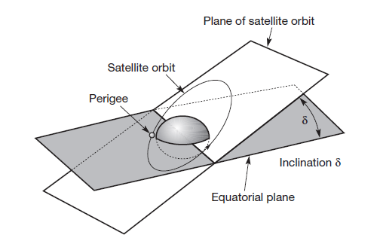

* The **elevation angle** *ε* is defined as the angle between the center of the satellite beam and the plane tangential to the earth’s surface.(called footprint)

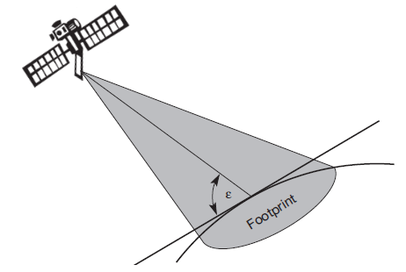

* Another effect of satellite communication is the propagation loss of the signals.
* This attenuation of the signal power depends on the distance between a receiver on earth and the satellite, and, additionally, on satellite elevation and atmospheric conditions.
* The loss *L* depending on the distance *r* between sender and receiver can be calculated as:

*L* = (4·π·*r·f* / *c*)2,

with *f* being the carrier frequency and *c* the speed of light.

Four different types of orbits can be identified:

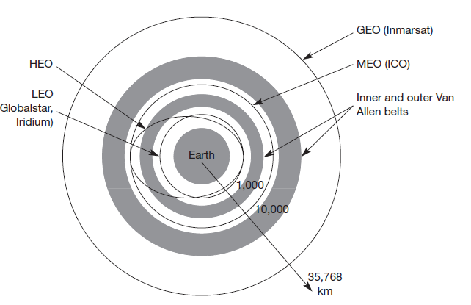

**Geostationary (or geosynchronous) earth orbit (GEO):** GEO satellites have a distance of almost 36,000 km to the earth.

Examples: All TV and radio broadcast satellites,

Many weather satellites and satellites operating as backbones for the telephone network.

**Medium earth orbit (MEO):** MEOs operate at a distance of about 5,000–12,000 km.

Example: Upcoming systems (e.g., ICO) use this class for various reasons

**Low earth orbit (LEO):** While some time ago LEO satellites were mainly used for espionage, several of the new satellite systems now rely on this class using altitudes of 500–1,500 km.

**Highly elliptical orbit (HEO):** This class comprises all satellites with noncircular orbits.

Currently, only a few commercial communication systems using satellites with elliptical orbits are planned.

**5.3.1 GEO**

* If a satellite should appear fixed in the sky, it requires a period of 24 hours.
* Using the equation for the distance between earth and satellite *r* = (*g*·*R*2/ (2·π·*f*) 2)**1/3** and the period of 24 hours *f* = 1/24h, the resulting distance is 35,786 km.
* The orbit must have an inclination of 0 degrees.

**Advantages:**

* Three GEO satellites are enough for a complete coverage of almost any spot on earth.
* Senders and receivers can use fixed antenna positions, no adjusting is needed.
* GEOs are ideal for TV and radio broadcasting.
* Lifetime expectations for GEOs are rather high, at about 15 years.
* GEOs typically do not need a handover due to the large footprint.
* GEOs do not exhibit any Doppler shift because the relative movement is zero.

**Disadvantages:**

* Transferring a GEO into orbit is very expensive.
* Northern or southern regions of the earth have more problems receiving these satellites due to the low elevation above latitude of 60°.
* Larger antennas are needed in this case.
* The transmit power needed is relatively high (some 10 W) which causes problems for battery powered devices.
* These satellites cannot be used for small mobile phones.

**5.3.2 LEO**

* As LEOs circulate on a lower orbit, it is obvious that they exhibit a much shorter period.
* LEO systems try to ensure a high elevation for every spot on earth to provide a high quality communication link.

**Advantages:**

* Transmission rates of about 2,400 bit/s can be enough for voice communication.
* The delay for packets delivered via a LEO is relatively low (approx 10 ms).
* Smaller footprints of LEOs allow for better frequency reuse, similar to the concepts used for cellular networks.
* LEOs can provide a much higher elevation in Polar Regions and so better global coverage.

**Disadvantages:**

* The biggest problem of the LEO concept is the need for many satellites if global coverage is to be reached.
* One general problem of LEOs is the short lifetime of about five to eight years due to atmospheric drag and radiation

**5.3.3 MEO**

* MEOs can be positioned somewhere between LEOs and GEOs, both in terms of their orbit and due to their advantages and disadvantages.

**Advantages:**

* Using orbits around 10,000 km, the system only requires a dozen satellites which is more than a GEO system, but much less than a LEO system.
* These satellites move more slowly relative to the earth’s rotation allowing a simpler system design
* Depending on the inclination, a MEO can cover larger populations, so requiring fewer handovers.

**Disadvantages:**

* Again, due to the larger distance to the earth, delay increases to about 70–80 ms.
* The satellites need higher transmit power and special antennas for smaller footprints.